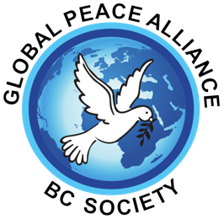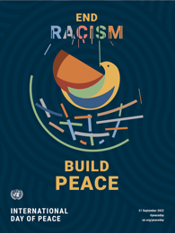

Festival Application Form 2022
- Name ___________________________.
- Introduction/description _______________________________________________________________________________________________________________________________________________________________________________________________________________

- Past experience if you are new __________________________________________________________________________________________________________________________________________.
- Submission video or audio if new Circle: Yes Will be sent
- The name of your performance _____________________________________________.
- Description/ short explanation of what you will be doing (a video of your performance if available). This will be your introduction to the audience. ____________________________________________________________________________________________________________________________________________________________________________________________________________________________________________________________________________________
- The number of people in your group, (our honorarium 125 single – 250+ depending on group size, more depending of sponsorship and finalist choice. ____________________
- Music requirements, microphones, memory stick, other _____________________________________________________________________.
- Lighting requirements/colors _____________________________________________________.
- Our check should be made out to ____________________________________________. (dispersed following the performance).

I/We agree to participate in the “End Racism, Make Peace Festival” on October 1, 2022.
Yes I adhere to the following rules
Arrival on time, 30 min before performance
Staying to the end of the program.
Following any health guidelines in effect.
Allowing live taping and pictures.

Authorized Signature: __________________________ (binding only if accepted to the festival)

Print name: __________________________ Date :

