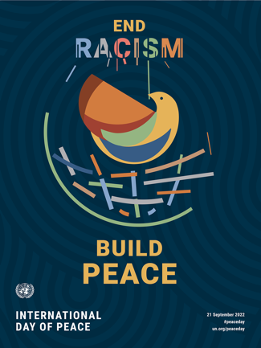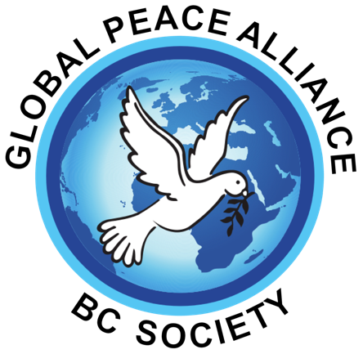

Global Peace Alliance BC (GPA) celebrates 10 years since it was formed by community leaders in Surrey based on our founding President’s book, A New Beginning for Humankind, a Recipe for Lasting Peace On Earth, by R.B Herath. Our vision is a world of peace based on justice, democracy, economic equity and environmental integrity - where humans celebrate their diversity, respect their common values, and resolve their conflict by non-violent means. To achieve our mission, we hold various educational activities, webinars, and engage in social justice issues, supporting causes that affect communities and the world at large. We are adamant that peace can’t ever be achieved without nuclear disarmament. The mere possession of doomsday weapons is the highest crime against humanity and all life.

We are part of the Canada Wide Peace and Justice Network which includes over 40 organizations.

Our yearly “Give Peace a Chance” festival celebrates the International Day of Peace, a day devoted worldwide to strengthening the ideals of Peace through observing 24 hours of non-violence and cease fire. We will once again welcome to our festival, speakers, dancers and singers to share their message of peace and express their vision for a better world. We will hear speakers on social, economic and environmental topics related to peace. Our welcome will include an indigenous blessing and message followed by a key note speaker on peace. The UN’s theme this year is End Racism, Build Peace. Next, a panel discussion of community leaders on ending racism and discussing solutions which could bring equity to marginalized and racialized communities will take place. The BC government has taken the step of collecting data to find out where problems lie and we want to begin to look at solutions to systemic racism, formed by colonial societal attitudes.

“ Racism, xenophobia and related discrimination and intolerance exist in all societies, everywhere. Racism harms not just the lives of those who endure it, but also society as a whole. We all lose in a society characterized by discrimination, division, distrust, intolerance, and hate. The fight against racism is everyone’s fight. We all have a part to play in building a world beyond racism.” UN Secretary-General Antonio Guterres

During lunch break, participants will have a chance to express their ideas and peace messages on murals, view our art exhibit from the 2021, 2022 peace submissions from young and old. Art winners will receive their prizes and awards following performances. Throughout the festival children are welcome to participate with a parent in various table activities. There will also be information tables from community organizations and cultural exhibits to enjoy.

After the break we will all come together to enjoy music, dance and song. We invite performers from communities, schools and artists to share their cultural talents and we also challenge them to deliver a message of peace, love, and nonviolence. The audience and judges will vote on 3 of the most artistic and inspiring performances that unite, delight and express a strong theme. These will receive prizes in in addition to our honorariums. We are calling on sponsors and the community to reach out to us info@peacealways.org. We will end our festival with audience participation in song and dance and a special surprise. We are very excited for this year’s festival, after a long pandemic. We are extremely thankful to be chosen for the use of the beautiful venue of the Bell Centre.

Our Peace Reflections
Let’s care and help others, not seek vengeance for wrongs, act responsibly and reliably, appreciate the well-being and happiness of all humans irrespective of differences!

Date: Saturday, October 1st
Time: 11:30 – 5:00
There is a minimal $5.00 fee for adults to cover expenses (but no one turned away)

